Week 6 Bias DAC Progress
Mentor discussion | October 4, 2026
Team Member: Henan | Date: October 4, 2026 | Week 6
Course: AMS Senior Design | Project: Programmable Bias Voltage DAC

Selected block: Capacitor DAC array
Includes the six TG reference switches; the Verilog-A driver is testbench stimulus.

Question 1
Based on the overall specifications you set for your project, what specifications should this block meet?
Current block target: a 3-bit capacitor DAC array with six TG reference switches, 1 V reference span, and eight ordered levels from 0 to 875 mV (125 mV/LSB). Use TT at 27 C with no added output load. A provisional functional screen is settled error within 0.25 LSB; report the actual error as well. The longer-term resolution, load, power and cryogenic limits remain draft items in the revised specification worksheet.

Question 2
What simulations do you need to run to verify this block meets those specifications?
Completed today: TG Ron versus signal voltage using a 1 mV differential; code 100 regression after replacing all six reference switches; Verilog-A driven 001 to 100 transition; ascending 000 to 111 scan. The eight displayed settled values are within 8.4 uV of their ideal levels. Next: verify timestep convergence, inspect the 011 to 100 glitch, run descending and large-step tests, then extract INL/DNL with a defined sampling rule. Load, leakage, noise, power, PVT and mismatch tests remain open.

Question 3
Why is this block a proper selection for your application and your overall specifications?
Capacitor ratios provide programmable voltage steps, and TGs support the present 0 to 1 V signal range. This is a useful baseline for a low-update-rate, high-impedance bias load. Suitability for a quantum-dot gate or the collaborator's analog bias interface depends on the actual load and noise requirement. Ideal references and behavioral control do not establish total system power.

Question 4
What are the main challenges in designing this block?
Ron is strongly signal dependent, with about 20 kOhm near midrange in the standalone test. Other challenges are switching disturbance, capacitor mismatch/parasitics, load-dependent gain and droop, and uncertain cryogenic models. The full-code scan shows a visible undershoot at 011 to 100. Reset is still ideal, and no cryogenic performance has been demonstrated.

Question 5
What circuit- or system-level solutions address those challenges?
Implemented: complementary TG controls, a 5 ns interval between old-path turn-off and new-path turn-on commands, shared supply nets, and a reusable Verilog-A sequencer. Next: choose TG size from settling and disturbance limits, evaluate reset implementation, assess MIM versus MOM using PDK/layout evidence, and use calibration or buffering only where the measured error/load requires it. Confirm the application, output load and temperature scope with the mentor.

Discussion Checklist
[x] Selected exactly ONE block and marked it clearly.
[x] All five questions answered, each grounded in your project's own specifications.
[x] Simulations listed in Question 2 are specific (named plots/sweeps), not generic.
[x] Challenges and solutions in Questions 4-5 are specific to this block, not generic circuit-design advice.
Mentor decisions: confirm the real load/application; set resolution and error budgets; identify cryogenic model/measurement resources and the reason for preferring MOM or a different MOS flavor.
Evidence scope: schematic-level nominal simulations. All six reference switches use core nch/pch TGs; reset, reference sources and control generation remain ideal or behavioral. No PEX, statistical yield, power or cryogenic result is claimed.

TG resistance baseline
TG sizes: NMOS W/L = 1 um / 60 nm; PMOS W/L = 2 um / 60 nm. VDD = EN = 1 V; VSS = ENB = 0 V. A = vtest, B = vtest + 1 mV; sweep vtest from 0 to 0.999 V in 0.01 V steps.
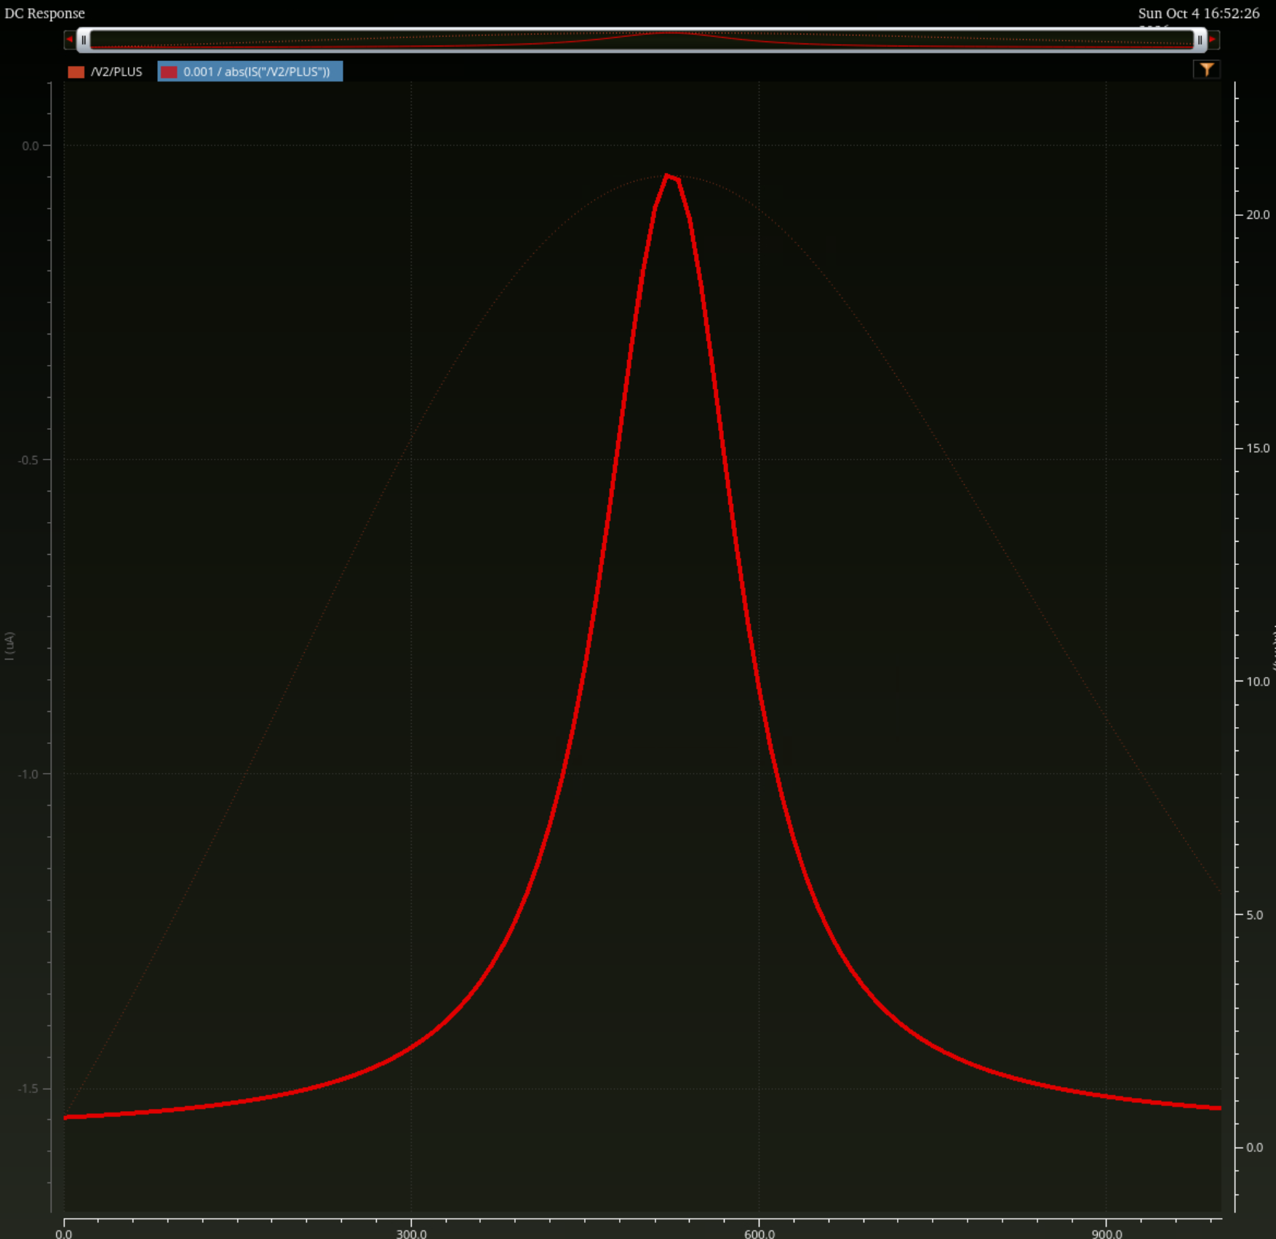
Figure 1. Ron = 0.001 / abs(I(V2/PLUS)). Resistance is the bright curve on the right axis; the left axis is current. At vtest = 0.51 V, |I| = 49.6226 nA gives about 20.15 kOhm. This is a local small-differential measurement, not a constant resistance for every DAC transition.
The high midrange resistance is a discussion point for sizing and headroom. The required Ron limit must come from the actual settling budget and effective load.

TG integration and turn off disturbance
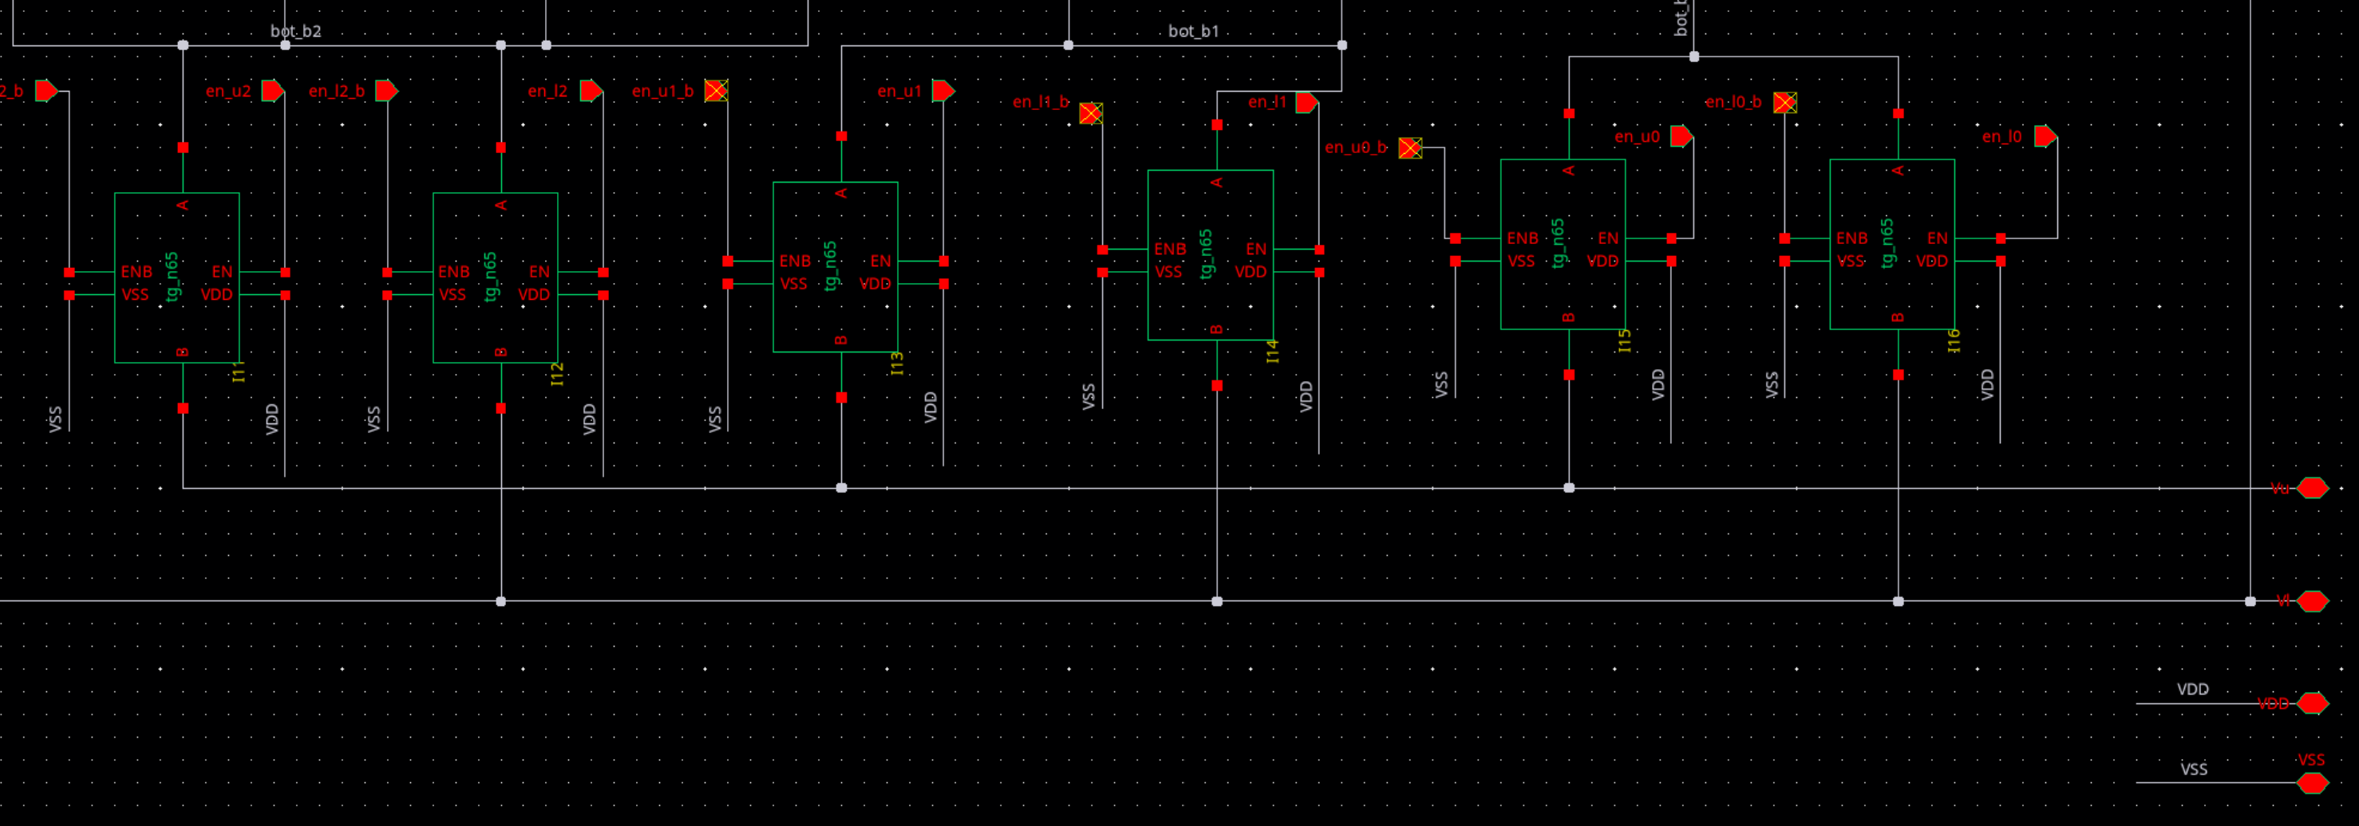
Figure 2. All six reference-selection switches replaced by tg_n65. VDD and VSS use shared named nets. The top-plate reset switch remains ideal.
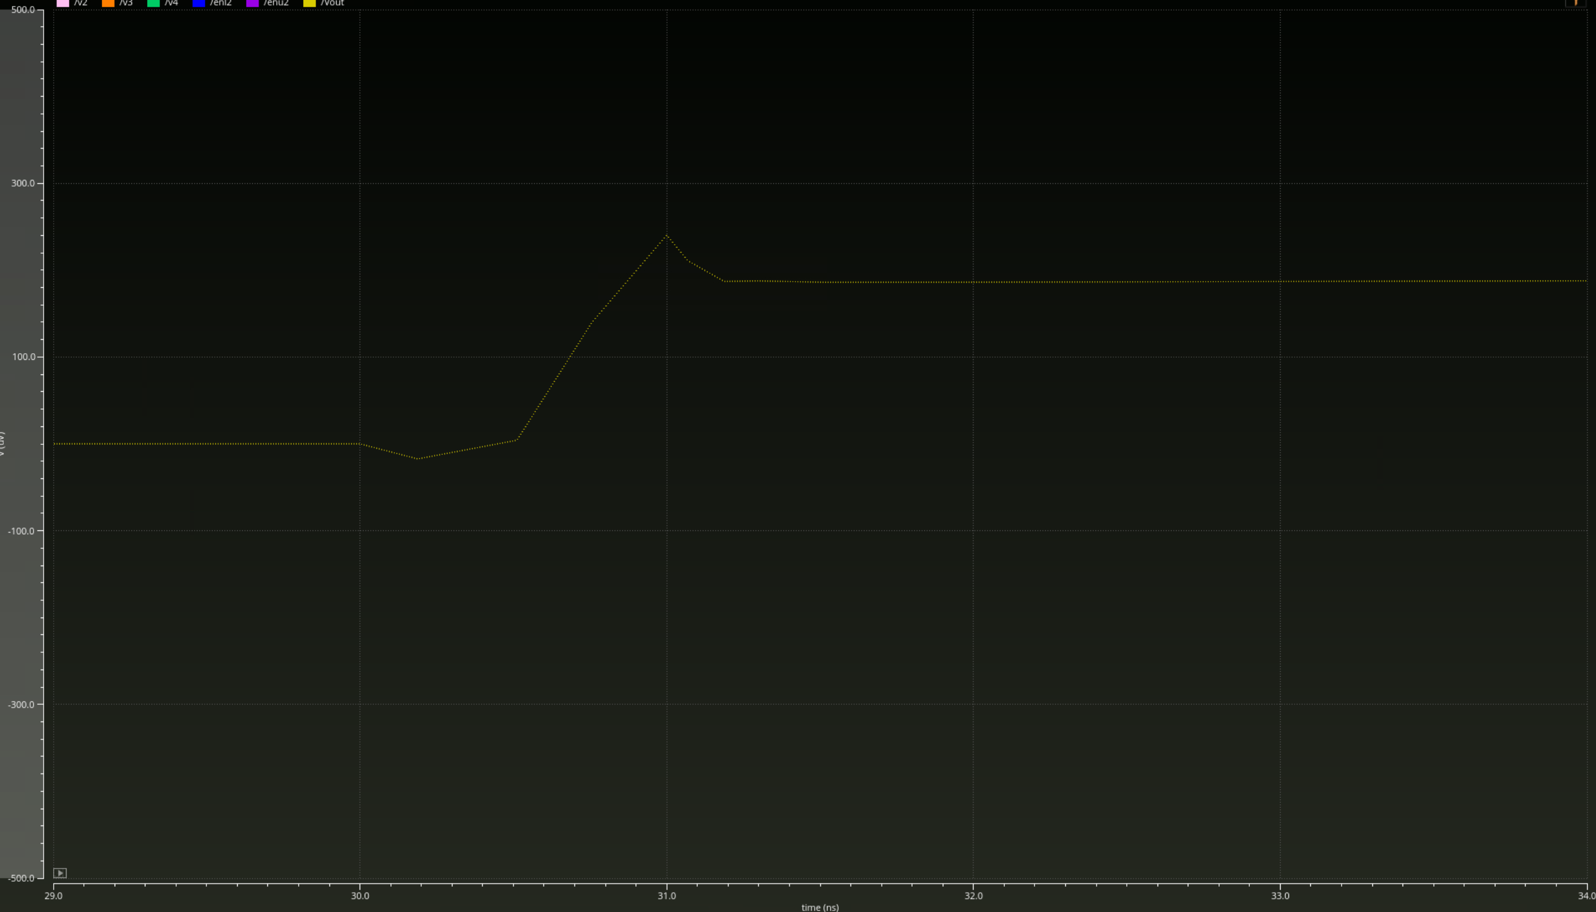
Figure 3. Earlier b2-only integration test: lower TG turn-off at 30 ns produces an estimated +185 uV retained step and approximately +240 uV peak at Vout. Values are image estimates; peak/duration need timestep verification. This is separate from final settled-code error.

Verilog A control and two code verification
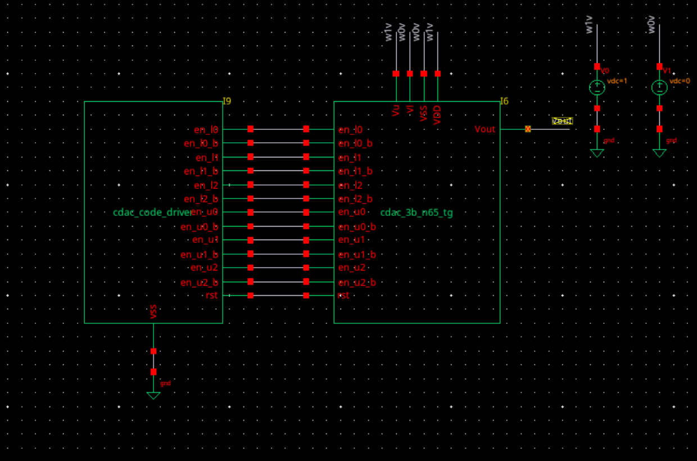
Figure 4. cdac_code_driver supplies 12 TG controls and rst. The DUT remains the MOS and PDK-capacitor schematic.
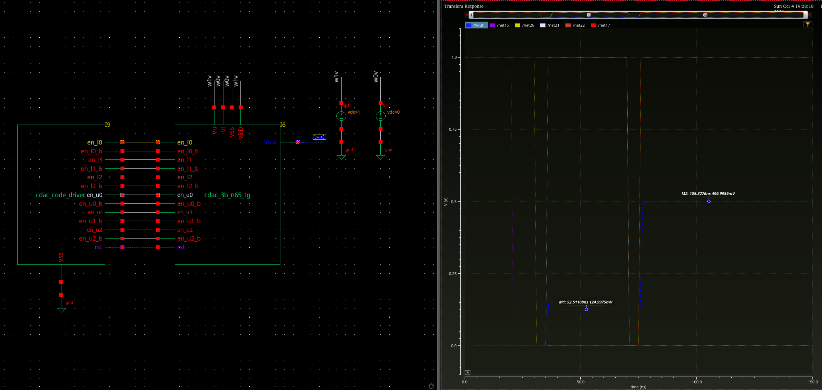
Figure 5. 001 to 100 test: reset release at 20 ns; initial break/make at 30/35 ns; second break/make at 70/75 ns; 1 ns edges; stop at 150 ns. Markers: 124.9975 mV at 52.51108 ns and 499.9959 mV at 105.3276 ns.

Full code scan
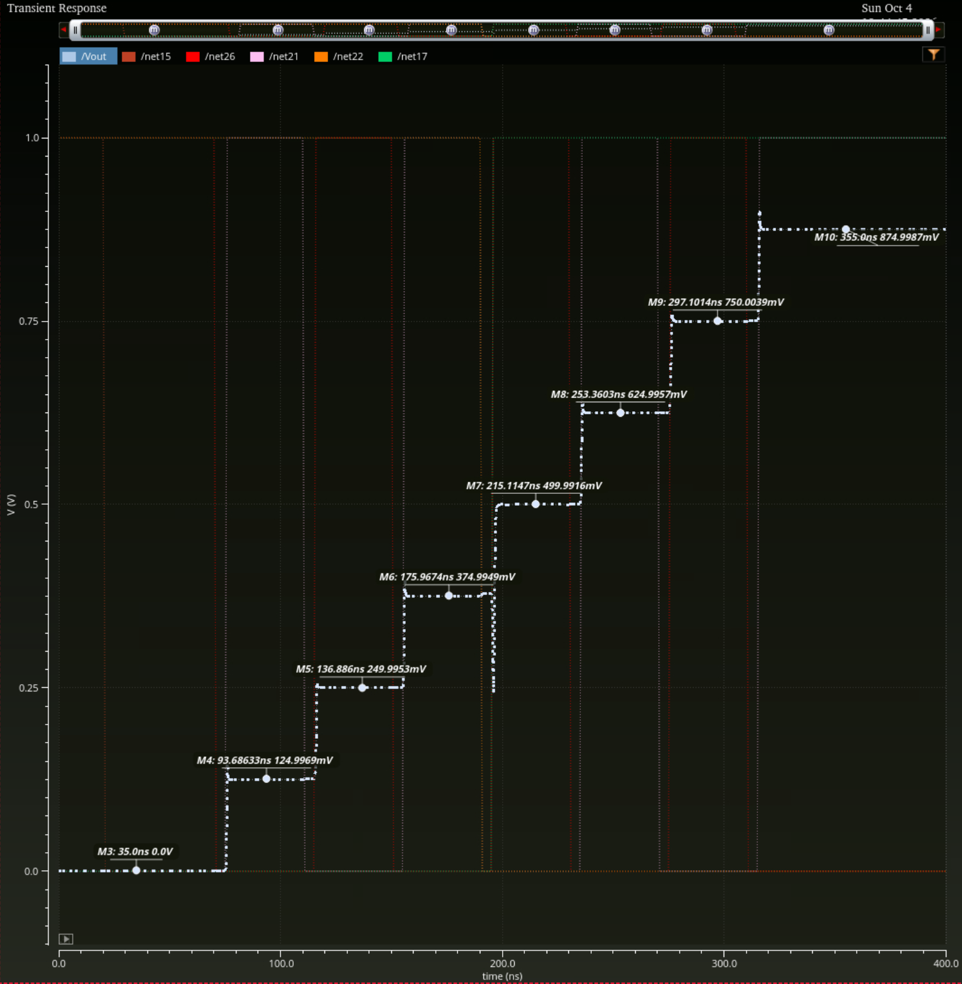
Figure 6. Ascending 000 to 111 scan. t_reset = 20 ns, t_apply = 30 ns, t_step = 40 ns, t_dead = 5 ns, t_edge = 1 ns; stop = 400 ns. The 011 to 100 transient needs separate glitch and settling analysis.
Code | Ideal mV | Marker mV | Error uV
000 | 0 | 0.0000 | +0.0
001 | 125 | 124.9969 | -3.1
010 | 250 | 249.9953 | -4.7
011 | 375 | 374.9949 | -5.1
100 | 500 | 499.9916 | -8.4
101 | 625 | 624.9957 | -4.3
110 | 750 | 750.0039 | +3.9
111 | 875 | 874.9987 | -1.3
Marker readings only; largest observed absolute error is 8.4 uV. This is not a measured INL/DNL, mismatch, or cryogenic accuracy specification. Minimum observed adjacent step is 124.9948 mV.

